IMPORTANT NOTE: The Following Pictures will not literally be used in our project. They’re displayed as examples to give a general idea of what features would be in our project.

Example 1.1

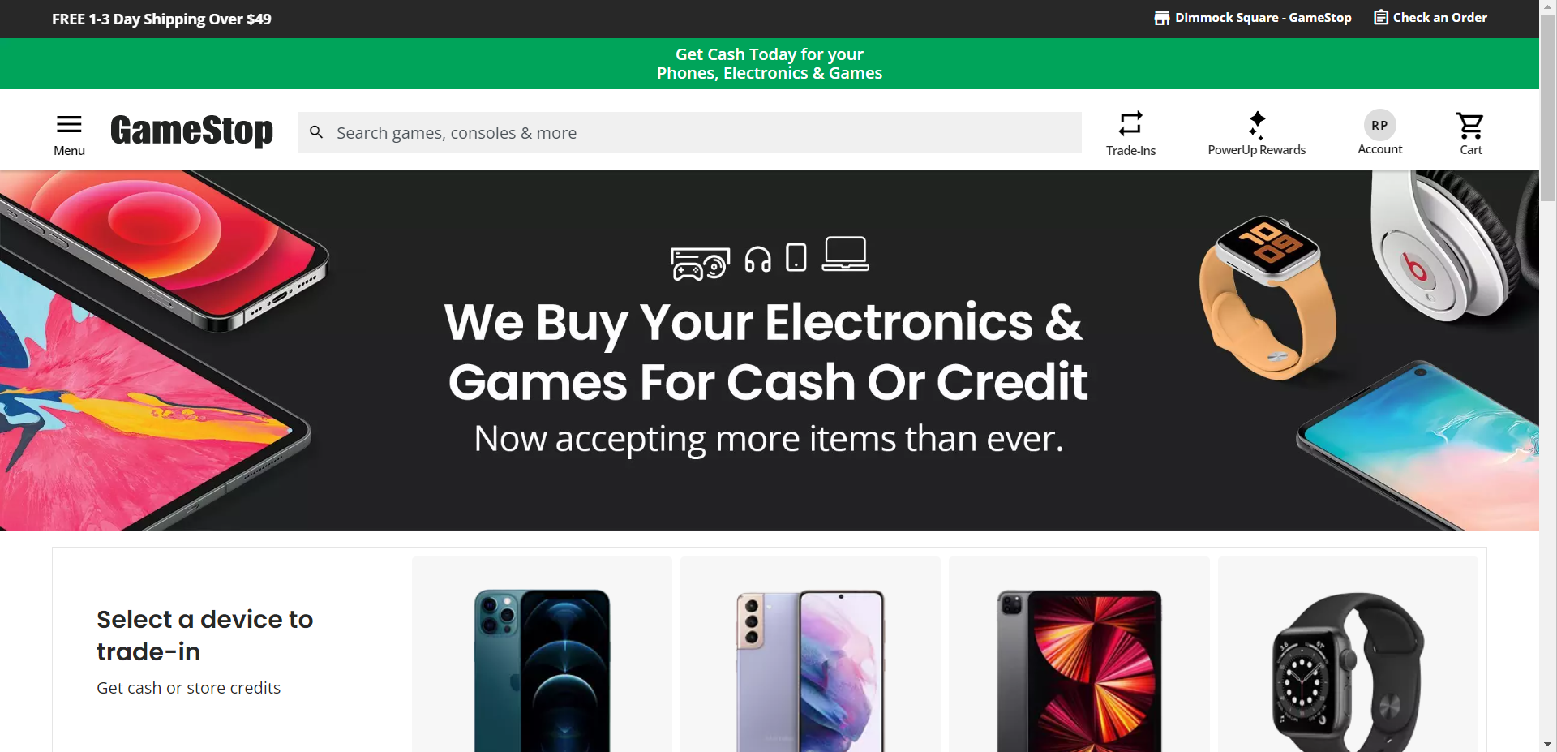

Example 1.2

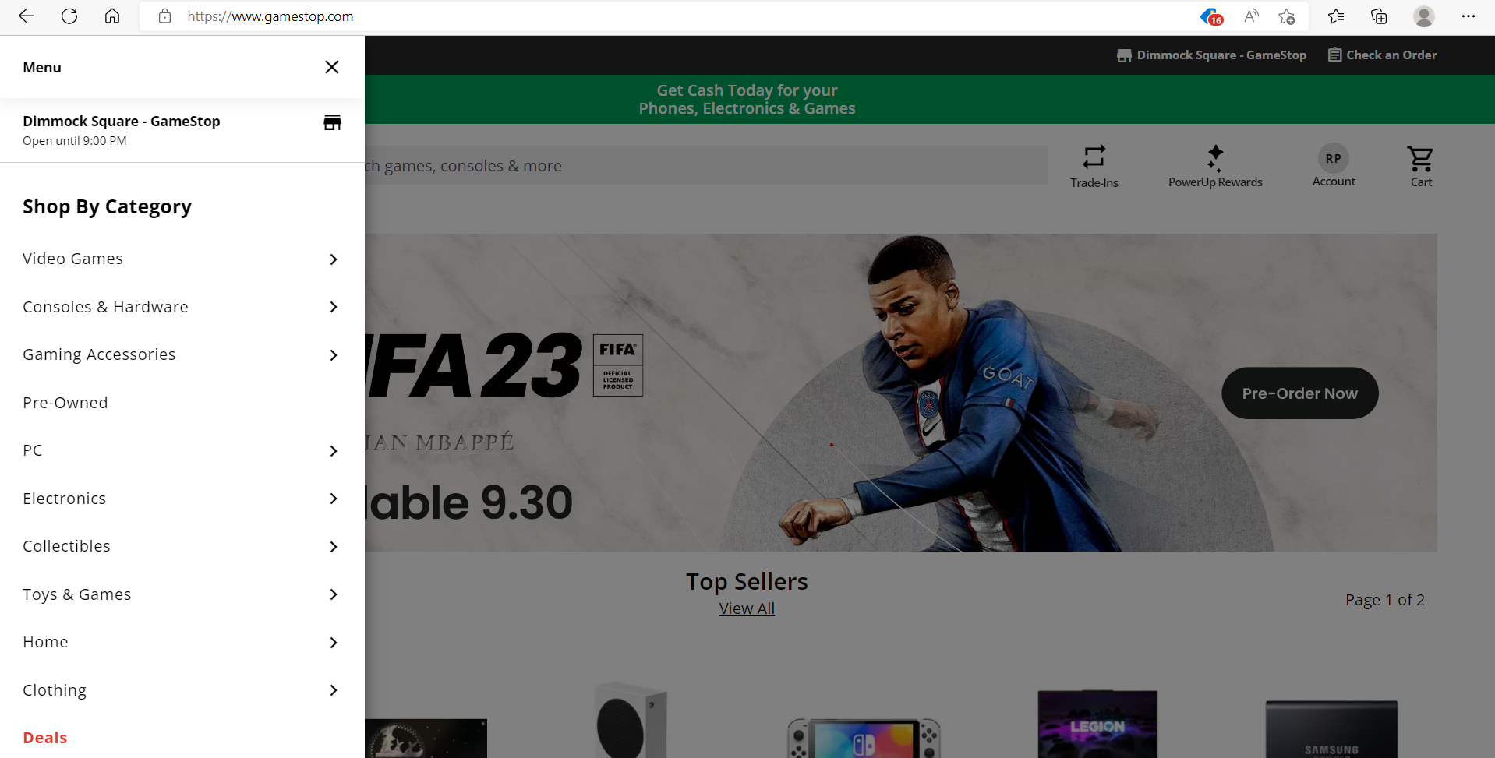

Example 1.3

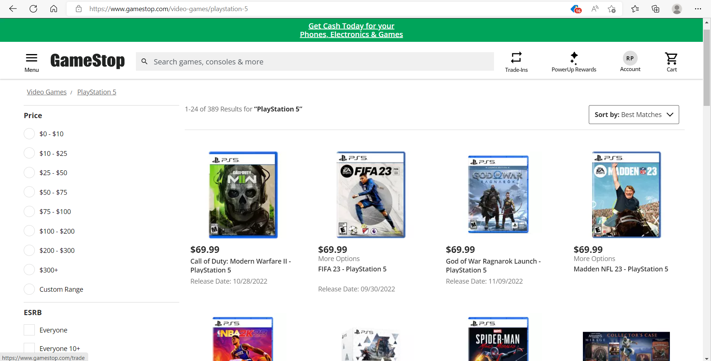

Summary 1:

.As a user of the add-on, I want to find out how much the price of a game costs.

. Feature 1.1: The menu (example 1.1) tab will be used as a navigation tool for our website.

.When it’s clicked on, then a list of categories will be displayed.

. Feature 1.2: The category list (example 1.2) will be sorted between games(games, consoles, accessories) and anime(anime, manga, accessories). For this example we want to search for a game.

.When I click on the videogame, then i’ll be sent to the videogame search page.

.Feature 1.3: The search bar (Example 1.3) is used to search for the game that the user is looking for.

. When the name of the game is typed in, then the website displays the game along with the price.

Example 2.1

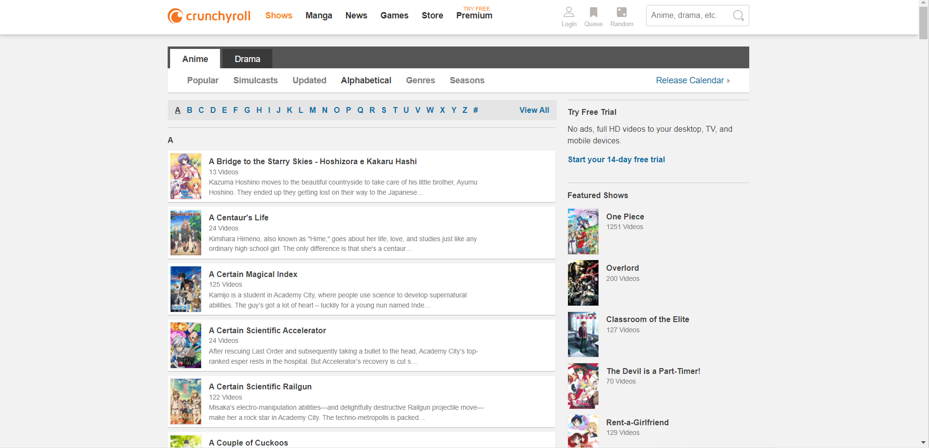

Summary 2:

As a user of the add-on, i want to search a random show to watch,

. Feature 2.1: If I want to search for an anime show, I want to look in the anime section of the category list where it lists shows. (example 1.2).

. When I click on the “Shows” label, then i’ll be sent to the anime show search page (example 2.1)

. Feature 2.2: the shows are listed in a dictionary list and sorted alphabetically. Let’s say for example I want to look up the show “Mob Psycho”

. When I click on the M tab of the list, then it’ll take me to the list of shows that start with the letter “M”.

. Feature 2.3: there also will be a search bar to look for it if someone wants to look for it quickly”

. When the name of the show is typed in, then the website will display the show.

Example 3.3

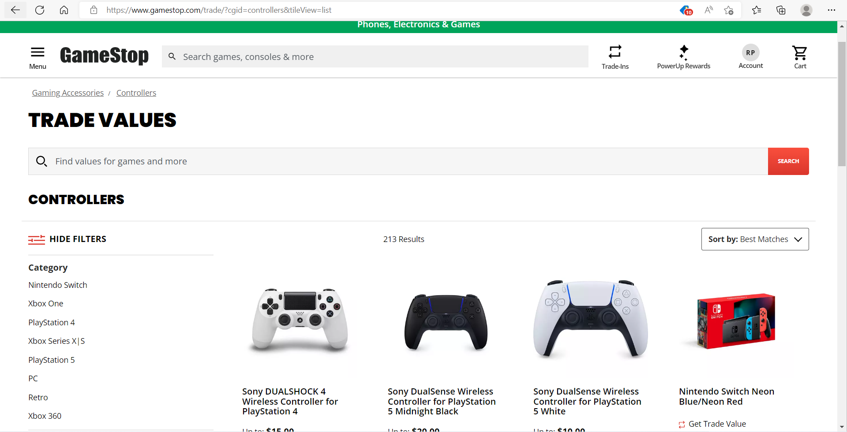

Summary 3:

.As a user of the add-on, I want to find out how much the price of a game costs.

. Feature 3.1: If I want to search for a new playstation 5 controller, I want to look in the game section of the category list where it lists “Accessories”. (example 1.2).

. When I click on the “Accessories” label, then i’ll be sent to the game accessories search page (example 3.1).

.Feature 3.2: The search bar (Example 3.1) is used to search for the accessory that I am looking for (Playstation 5 controller).

. When I type in “Playstation 5 controller” , then the website displays the controller with its price.